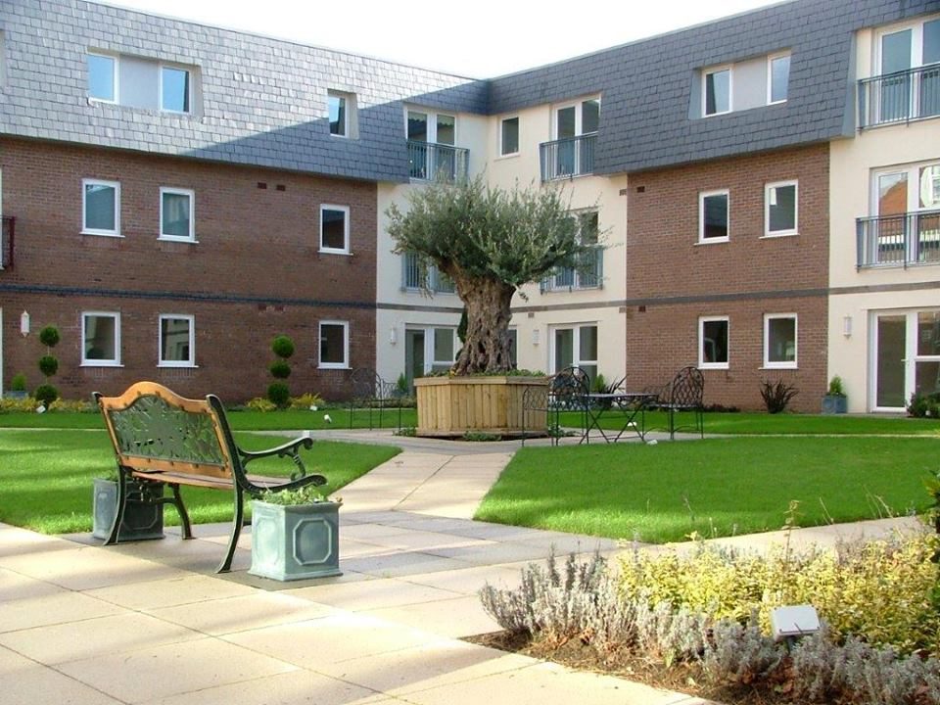

**Campion Gardens Extra Care Facility – 130 Bed Care Home**

**Design, manufacture and erection of a purpose built extra care facility. Constructed in 2008, Seven Oaks provided the timber frames, loose joists, mansard roof structures for this 130 bed facility . The facility was constructed over two phases with the first phase consisting of two three storey bloacks accommodating 92 residents in 88 single and 1 shared rooms (65 en suite). The second phase consisted of an additional three storey block assisted living scheme comprising of 30 number 2 bedroom apartments.**

**This was a luxury development with facilities including restaurant, coffee lounge, cocktail bar,**

**library, cinema, visitor suites, relaxation rooms and an on-site surgery and beauty salon.**

**Type of Project – Extra Care**

**Client – Hale Construction**